|  |
| --- |
| EPAM Systems, RD Dep.  MTN.*NIX.07 Oracle DB. Introduction to DWH |
| MTN.*NIX.07 Labs - Dimension and Facts Basics |

|  |  |  |  |  |  |
| --- | --- | --- | --- | --- | --- |
| REVISION HISTORY | | | | | |
| Ver. | Description of Change | Author | Date | Approved | |
| Name | Effective Date |
| 1.0 | Initial status of document | [**Kiryl Bucha**](mailto:Kiryl_bucha@epam.com) | 16-JAN-2012 |  |  |
|  |  |  |  |  |  |

*Contents*

1. Prerequisites Task 3

1.1. Passwords Index 3

1.2. Folder Paths Index 3

2. Create and populate Dimension of TIME DW – Layer 3

2.1. Task 01: CREATE DW.T_DAYS 3

2.2. Task 02: CREATE DW.T_WEEKS 4

2.3. Task 03: CREATE DW.T_MONTHS 4

2.4. Task 04: CREATE DW.T_QUARTERS 4

2.5. Task 05: CREATE DW.T_YEARS 4

3. OLAP – Business analyses task 4

3.1. Task 06 – Solution concept – Add: Chapter Dimensions Types 4

3.2. Task 07 – Solution concept – Add: Chapter Dimensions Hierarchies 5

3.3. Task 08 – Solution concept – Add: Chapter Facts Aggregations 6

# Prerequisites Task

## Passwords Index

|  |  |  |
| --- | --- | --- |
| Password Group | Login Name | Password |
| Operation System | root | “rootadmin” |
|  | oracle | “oracleadmin” |
|  |  |  |
| Oracle System | sys | “sysadmin” |
|  | system | “sysadmin” |
|  |  |  |
| Oracle Users | All DB users | “%PWD%” |
|  |  |  |
|  |  |  |

## Folder Paths Index

|  |  |  |
| --- | --- | --- |
| Path Group | Path Description | Path |
| Operation System | Oracle RDBMS – BIN | /oracle/app/oracle |
|  | Oracle Inventory | /oracle/app/oraInventory |
|  | Oracle Database Storage | /oracle/oradata |
|  | Oracle Install Directory | /oracle/install |
| Oracle | ORACLE_BASE | /oracle/app/oracle |
|  | ORACLE_HOME | $ORACLE_BASE/product/11.2 |
|  |  |  |
| FTP | ftp Incoming Folder | **/ftp/incoming** |
|  |  |  |
|  |  |  |

# Create and populate Dimension of TIME DW – Layer

**Notes:**

To Populate Time dims use External Resources:

|  |  |
| --- | --- |
| File Name | Path |
| Calendars.sql | … \Topic 07 - Dimension and Facts Basics\LabScripts\ |

## Task 01: CREATE DW.T_DAYS

**The Main Task** is to create Physical diagram and Objects on DW layer:

**Task Results:**

Create document, which contained next chapters:

* + Physical diagram store on GIT
  + Links to Scripts on GIT

## Task 02: CREATE DW.T_WEEKS

**The Main Task** is to create Physical diagram and Objects on DW layer:

**Task Results:**

Create document, which contained next chapters:

* + Physical diagram store on GIT

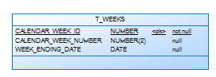

* + Links to Scripts on GIT

## Task 03: CREATE DW.T_MONTHS

**The Main Task** is to create Physical diagram and Objects on DW layer:

**Task Results:**

Create document, which contained next chapters:

* + Physical diagram store on GIT

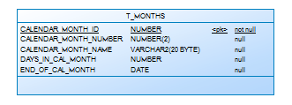

* + Links to Scripts on GIT

## Task 04: CREATE DW.T_QUARTERS

**The Main Task** is to create Physical diagram and Objects on DW layer:

**Task Results:**

Create document, which contained next chapters:

* + Physical diagram store on GIT

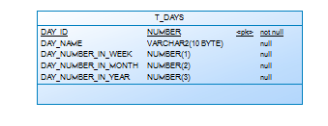

* + Links to Scripts on GIT

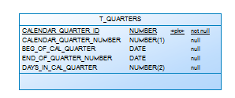

## Task 05: CREATE DW.T_YEARS

**The Main Task** is to create Physical diagram and Objects on DW layer:

**Task Results:**

Create document, which contained next chapters:

* + Physical diagram store on GIT

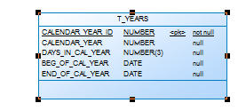

* + Links to Scripts on GIT

# OLAP – Business analyses task

## Task 06 – Solution concept – Add: Chapter Dimensions Types

**The Main Task** is to create summary table to describe all future STAR Dimensions:

Next points are mandatory:

* Start scheme must use no less one of SCD type 2 Dimension
* Start scheme must use prepared dimensions: DIM_TIME, DIM_GEO_LOCATIONS
* Start scheme must use one of period dimensions: DIM_GEN_PERIODS

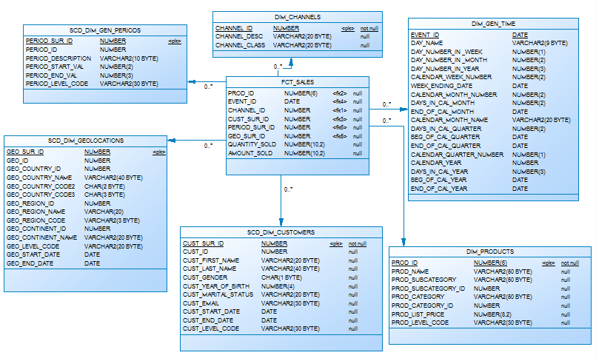

**Task Results:**

Create document, which contained next chapters:

* + Chapter: Dimensions Types Description

|  |  |  |  |  |
| --- | --- | --- | --- | --- |
| Name | Type | Size | DW – Merged Dimensions | Descriptions |
| DIM_GEN_TIME | SCD1 | BIG | DW.T_DAYS, DW.T_WEEKS, DW.T_MONTHS, DW.T_QUARTERS,  DW.T_YEARS | Dimension describe time parameters of the business |
| SCD_DIM_GEOLOCATIONS | SCD2 | SMALL | DW.T_COUNTRIES  DW.T_CNTR_GROUPS  DW.T_CNTR_SUB_GROUPS  DW.LC_CNTR_GROUPS  DW.T_GEO_TYPES  DW.T_GEO_SYSTEMS  DW.LC_GEO_SYSTEMS  DW.T_GEO_PARTS  DW.T_GEO_REGIONS  DW.T_GEO_OBJECTS  DW.T_CNTR_GROUP_SYSTEMS  DW. LC_CNTR_GROUP_SYSTEMS  DW.LC_CNTR_SUB_GROUPS  DW.LC_ GEO_PARTS  DW.LC_COUNTRIES  DW.LC_ GEO_REGIONS | Describe locations of sales |
| SCD_DIM_CUSTOMERS | SCD2 | BIG | DW.T_CUSTOMERS  DW.T_GENDER  DW.T_MARITAL_STATUS  DW.T_EMAIL | Describes customers |
| DIM_CHANNELS | SCD1 | SMALL | DW.T_CHANNEL_DESC  DW.T_CHANNEL_CLASS | Describe channels of sales |
| SCD_DIM_GEN_PERIOD | SCD2 | SMALL | DW.T_PERIOD_DESC  DW.T_PER_START  DW.T_PER_END  DW.T_LEVEL_CODE | Describe age period of customers. |
| DIM_PRODUCTS | SCD1 | BIG | DW.T_PRODUCT_DESC  DW.T_PROD_SUBCAT  DW.T_PROD_CAT | Describe products of the company |

## Task 07 – Solution concept – Add: Chapter Dimensions Hierarchies

**The Main Task** is to create summary table to describe all future STAR Dimensions Hierarchies:

Next points are mandatory:

* Start scheme must use no less one of SCD type 2 Dimension
* Start scheme must use prepared dimensions: DIM_TIME, DIM_GEO_LOCATIONS
* Start scheme must use one of period dimensions: DIM_GEN_PERIODS

**Task Results:**

Create document, which contained next chapters:

* + Chapter: Dimensions Hierarchies

**DIM_GEN_TIME:**

**DIM_GEN_TIME:**

**Hierarchy DAY-WEEK-MONTH-YEAR**

|  |  |  |  |
| --- | --- | --- | --- |
| Name | LEVEL_CODE | LEVEL_DESC | LEVEL_NATURAL_KEY |
| DAYs | DAY | Store day at the calendar | DAY_ID |
| WEEKs | WEEK | Store weeks at the calendar year | WEEK_ID |
| MONTHs | MONTH | Store months at the calendar year | MONTH_ID |
| YEARs | YEAR | Store years at the calendar year | YEAR_ID |
|  |  |  |  |

**Hierarchy DAY--MONTH- QUARTER -YEAR**

|  |  |  |  |
| --- | --- | --- | --- |
| Name | LEVEL_CODE | LEVEL_DESC | LEVEL_NATURAL_KEY |
| DAYs | DAY | Store day at the calendar year | DAY_ID |
| MONTHSs | MONTH | Store months at the calendar year | WEEK_ID |
| QUARTERs | QUARTER | Store quarters at the calendar year | QUARTER_ID |
| YEARs | YEAR | Store years at the calendar year | YEAR_ID |
|  |  |  |  |

**DIM_PRODUCTS:**

**Hierarchy PRODUCTS –-SUBCATEGORY-- CATEGORY**

|  |  |  |  |
| --- | --- | --- | --- |
| Name | LEVEL_CODE | LEVEL_DESC | LEVEL_NATURAL_KEY |
| PRODUCTS | PROD_NAME | Store products for each category. | PROD_ID |
| SUBCATEGORIES | PROD_SUBCATEGORY | Store product subcategories for each category. | PROD_SUBCATEGORY_ID |
| CATEGORIES | PROD_CATEGORY | Store product categories. | PROD_CATEGORY_ID |
|  |  |  |  |

**DIM_GEO LOCATIONS:**

**Hierarchy COUNTRY –-SUBREGION--REGION**

|  |  |  |  |
| --- | --- | --- | --- |
| Name | LEVEL_CODE | LEVEL_DESC | LEVEL_NATURAL_KEY |
| COUNTRIES | COUNTRY_NAME | Store countries for each region. | COUNTRY_ID |
| SUBREGIONS | COUNTRY_SUBREGION | Store sub regions for each region. | COUNTRY_SUBREGION_ID |
| REGIONS | COUNTRY_REGION | Store regions of the world. | COUNTRY_REGION_ID |
|  |  |  |  |

## Task 08 – Solution concept – Add: Chapter Facts Aggregations

**The Main Task** is to create summary table to describe all future STAR Fact Table Aggregations:

Next points are mandatory:

* Create more than one measurement
  + Summarize aggregation
  + Additional task: Not Additive measurement

**Task Results:**

Create document, which contained next chapters:

* + Chapter: Facts Aggregations

|  |  |  |  |  |
| --- | --- | --- | --- | --- |
| Name | Code | Table Name | Additive | Descriptions |
| Counts amount sold products | AMOUNT_SOLD | FCT_SALES | + | Calculate distinct values of Sales for the event period. |
| Counts quantity sold products | QUANTITY_SOLD | FCT_SALES | + | Calculate values of Products for the event period. |